Follow this link to complete the Case Study, “Twist the Plot” (Links to an external site.). If prompted, use your IUPUI login and password to access the site. (If you encounter any difficulties accessing this link, please notify instructor as soon as possible)

I already answered the questions please follow my answer as your own so you can complete this assignment

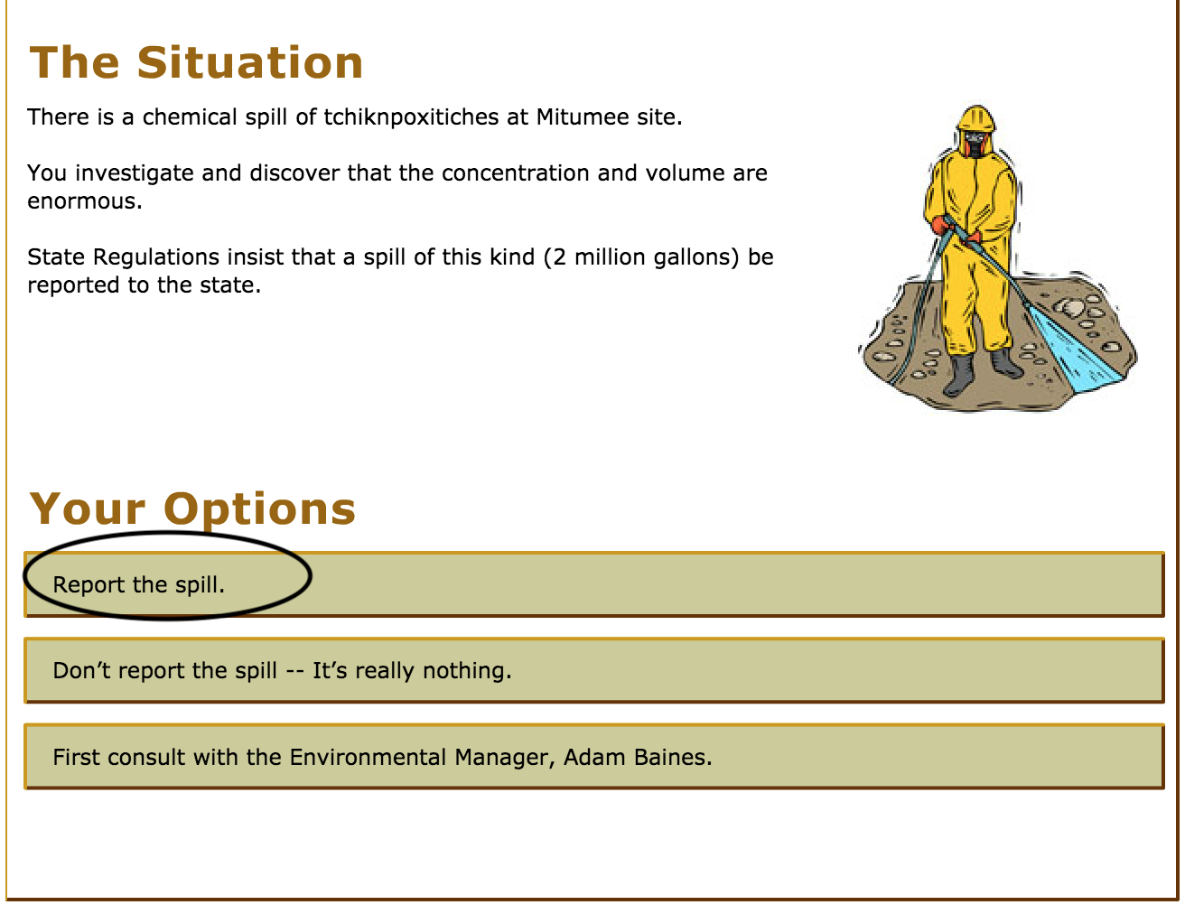

This was the beginning of the situation my answer is Report the spill

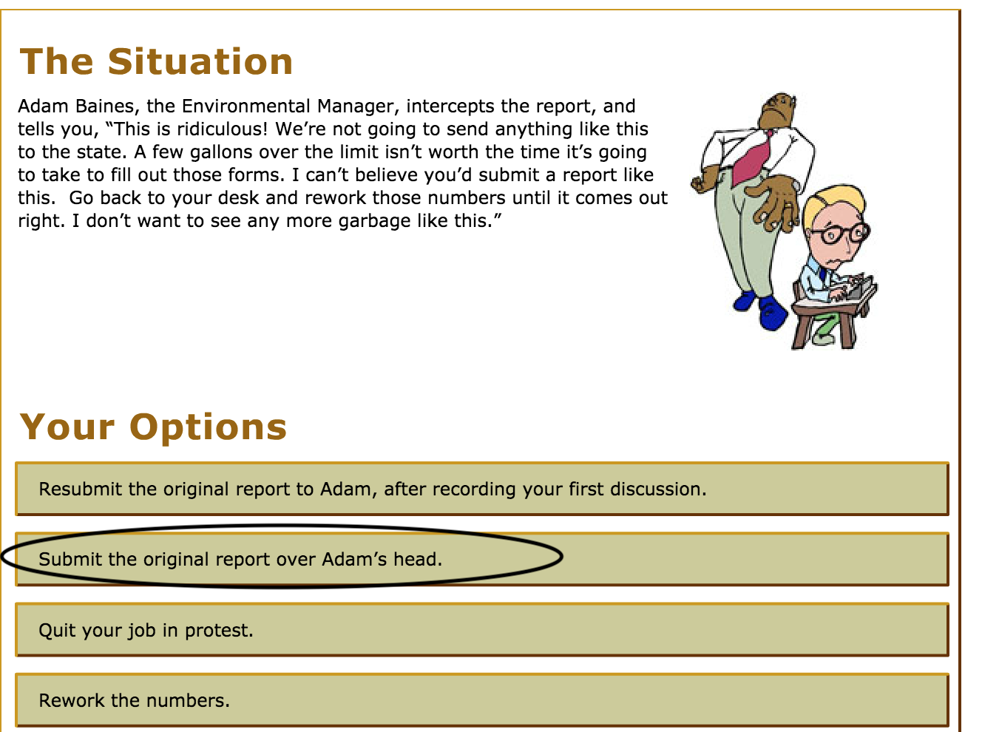

After that I submit the original over Adam’s head as you can see in this picture.

Then 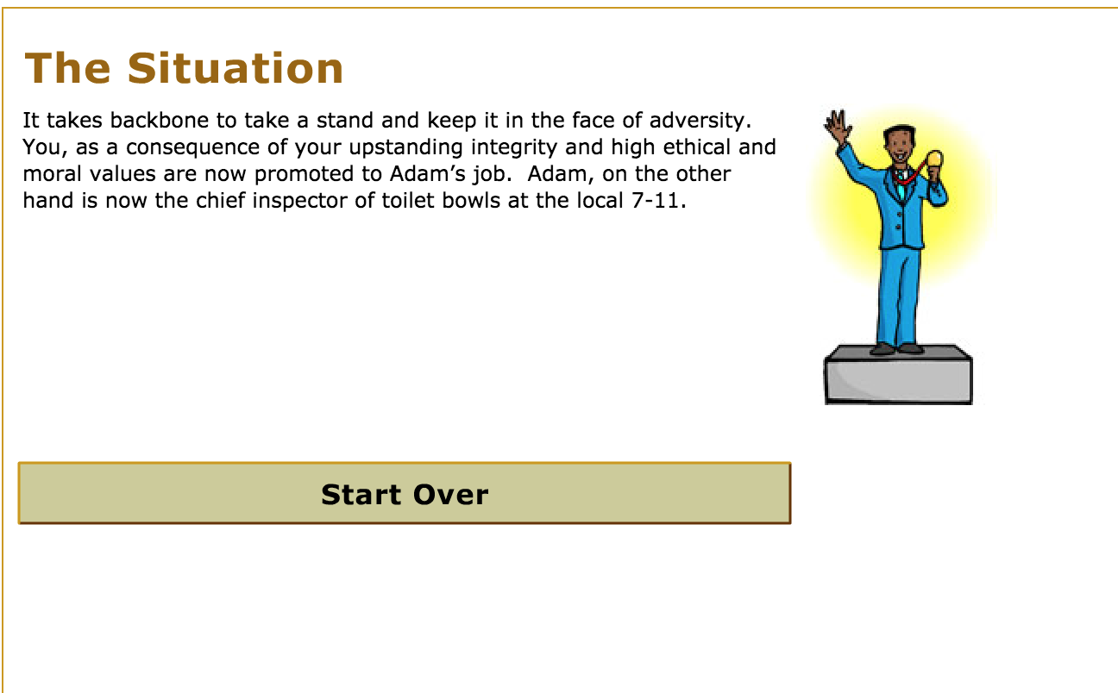

Follow this link to complete the Case Study, “Twist the Plot” (Links to an external site.). If prompted, use your IUPUI login and password to access the site. (If you encounter any difficulties accessing this link, please notify instructor as soon as possible)
Discuss, in a paper, how you would handle the “Twist the Plot” problem using the utilitarian, duty, rights and virtue ethics points of view. As you respond to this situation, include a discussion section of each pairing one perspective (listed below) with one of the "ethics point of view" listed above.
i.e. For each perspective: choose one of the ethics points of view in your response, but make sure to use all 4. There are five perspectives and four ethics point of view, so you will use one of the "ethics point of view" twice.
- A member of the state's environmental protection agency.
- The CEO of XYZ.
- Attorneys at XYZ who handle environmental affairs.
- Other industries faced with similar environmental problems.
- Members of the community whose health may be adversely affected if XYZ and other industries do not responsibly handle environmental problems.

Your document must include responses for all five perspectives (EPA, CEO, Attorneys, Other industries, and Community members). For each individual perspective choose just one of the 4 “ethics point of view” and state the point of view with supporting detail and example(s). There are four ethical points of view (utilitarian, duty, rights and virtue), you must use all 4 points of view. Since there are five perspectives you will use one ethical point of view twice.
Your submitted word document should follow proper writing format
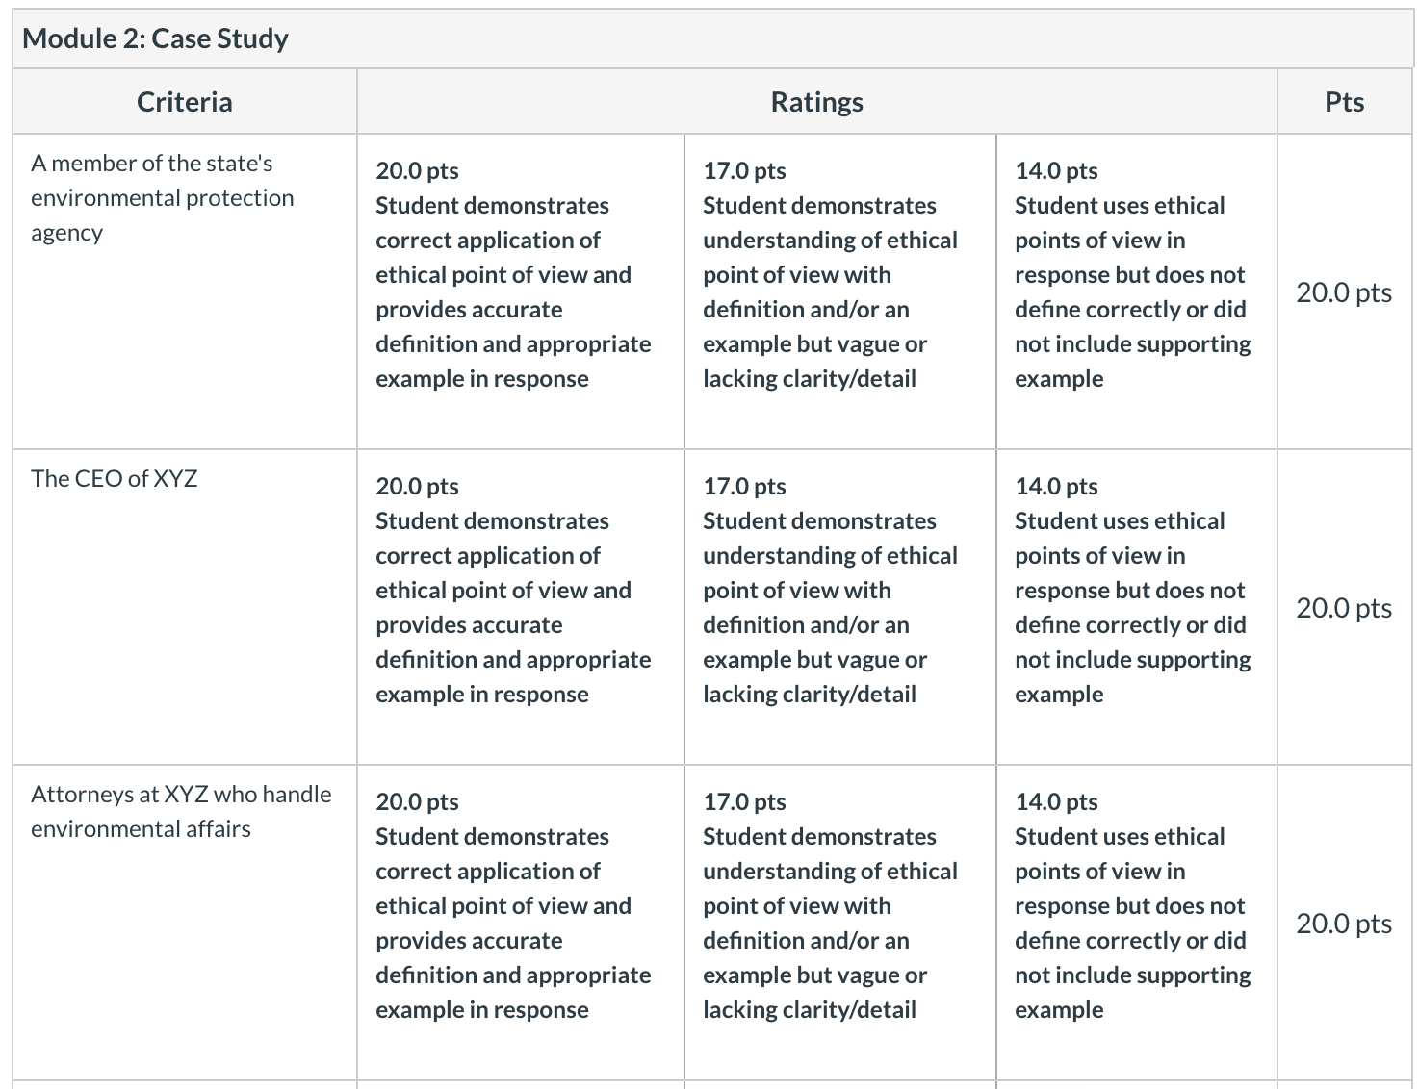
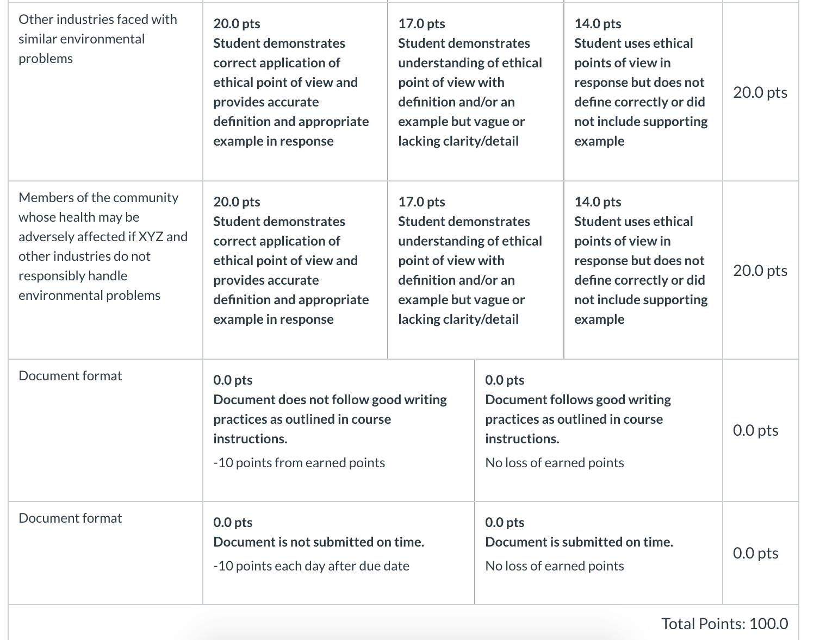
When you are done, submit your well-formatted paper here.

